MGMS – Proposal Management

Detailed Design Document

Ver. 1.4

Version History
Date | Description

Table of Contents

Version History 2
1 Introduction 4
1.1 Purpose 4
1.2 Scope 4
1.3 Assumptions 4
1.4 Constraints 4
Sub menu – Proposal Management 5
2 Data Dictionary 7

Introduction

This document provides the detailed design specifications for the Multisite Grant Management System project.

This is not a project plan nor does it detail the source code. It is a guide for system architecture and development, not for phasing, timelines or deliverables.

Finally, this is a ‘living document’ and the specification will change, continuously, as the project proceeds. More details will be added and the existing information edited as the requirements, architecture and design evolve in the course of the project.

Sub menu – Proposal Management

This section lists out all the notifications published by all the institutions in the GMS.

On this page, the interested institution users (prospective grantees) can:
- View the project name, notification date, grantor institution’s name, last date for submission of proposal etc.
- View the notification details
- Upload their proposal thereby setting a status “Submitted” and then
- Apply for the project.

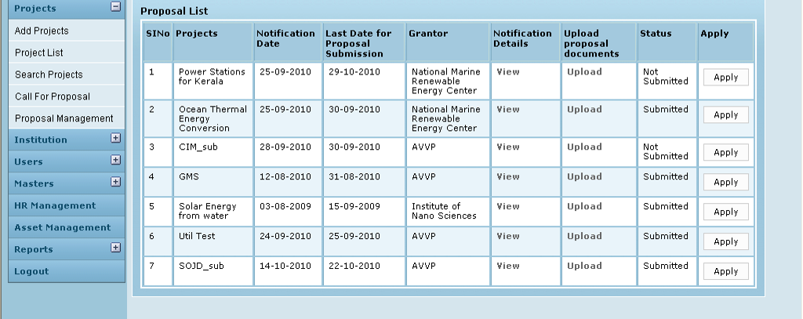

Field /Label | Input-Control | Data Type | Remarks
Proposal List
SlNo | Auto increment populated
Projects | Auto populated | varchar(255) | projects>name
Notification Date | Auto populated | datetime | notification>notification_date
Last Date for Proposal Submission | Auto populated | datetime | notification>  proposal_submission_last_date
Grantor | Auto populated | varchar(255) | party>name_of_the_institution
Notification Details | “View” - link
Upload Proposal documents | “Upload” - link
Status | Auto populated | varchar(255) | proposal>lockedyn
Apply | “Apply” - button

Upload Attachments

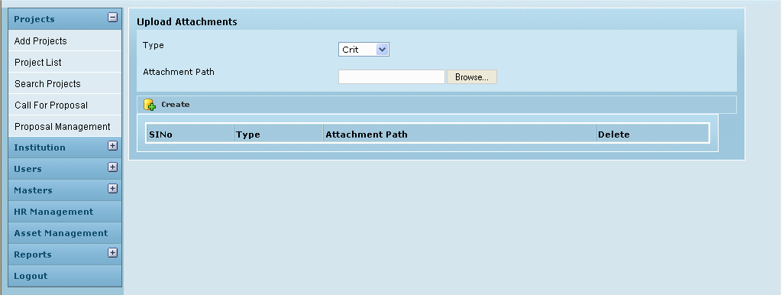

Field /Label | Input-Control | Remarks
Type | Listbox | attachment_type>type
Attachment Path | Text box – auto populated | Upload file
 | “Browse” button
Create | Button
(table fields)
SlNo | Auto populated
Type | Auto populated | attachment_type>type
Attachment Path | Auto populated | notifications_attachments> attachment_path
Delete | Button | Removes attachment

Associated Tables

(page below)
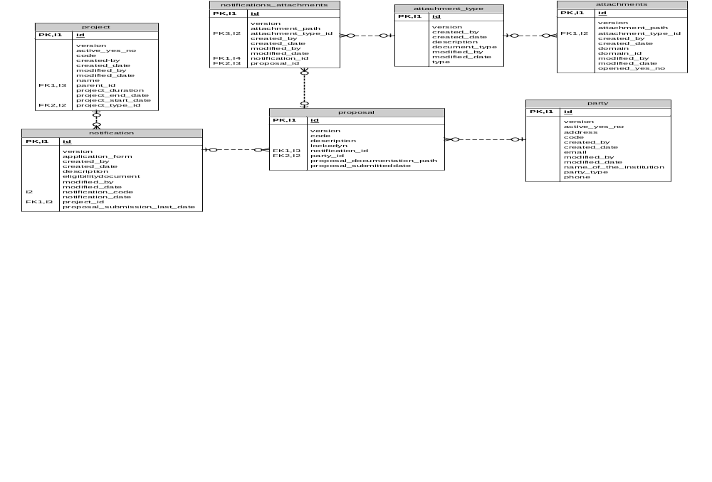

Data Dictionary

